LAB 1:
Digital Image Processing Lab:

IMAGE:
Function of 2 variables, 𝑓(𝑥,𝑦), where 𝑥 and 𝑦 are spatial coordinates,
Pixels:
Elements of the digital image, each has intensity.
Intensity:
The amplitude of gray level (in grayscale images)
Image Resolution:
The level of detail contained in an image. it refers to the number of pixels that exist within that image.
Sampling:
Digitizing Coordinate values
Quantization:
Digitizing Amplitude values
Types of images:
- Black and White(0,1)
- Gray Scale (0 – 255)
- Color Image(R,G,B{each 0-255})

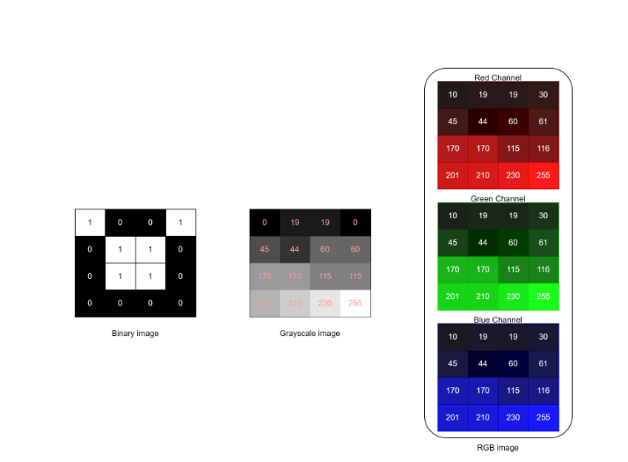

Task:
Why we use open CV?
Import and read/show black and white and gray image.
How number of resolution effect our image.
Numpy Arrays
Application of Sampling and Quantization.

